2. Multimedia Element: Image
Image in Multimedia
Still images are the important element of a multimedia project or a web site. In order to make a multimedia presentation look elegant and complete, it is necessary to spend ample amount of time to design the graphics and the layouts. Competent, computer literate skills in graphic art and design are vital to the success of a multimedia project.
Images come in many different formats such as Photographs, Paintings, Drawings, Symbols, Corporate logos, Flags, Maps, Diagrams, and Graphs.
Images can be used to: Provide facts, explain a process, Set a mood, Evoke an idea, Pinpoint locations, Illustrate relationships, Tell stories, Compare, Identify.
Digital Image
A digital image is represented by a matrix of numeric values each representing a quantized intensity value. The points at which an image is sampled are known as picture elements, commonly abbreviated as pixels. The pixel values of intensity images are called gray scale levels (we encode here the “color” of the image). The intensity at each pixel is represented by an integer and is determined from the continuous image by averaging over a small neighborhood around the pixel location.
An image must be converted to numerical form before processing. This conversion process is called digitization that means an image is broken into thousands of pixels and stored in this way is called a bitmap. Pixels are represented by three numbers. Red 0-255, Blue 0-255, Green 0-255.
Image Representation
The digital image I (r, c) is represented as a two- dimensional array of data, where each pixel value corresponds to the brightness of the image at the point (r, c). When I is a two-dimensional matrix, then I(r,c) is the intensity value at the position corresponding to row r and column c of the matrix , one row (r) or column (c) is called a vector.
Sampling: is a process of measuring the value of the image function f(x,y ) at discrete intervals in space. Each sample corresponds to a small square area of the image, known as a pixel. A digital image is a two- dimensional array of these pixels.
Quantization: is the representation of the brightness of each pixel by an integer value. Since digital computer process number, it is necessary to reduce the continuous measurement value to discrete units and represent them by integer number.
Bitmap: The two-dimensional array of pixel values that represents the graphics/image data.
Image resolution: refers to the number of pixels in a digital image. Fairly high resolution for such an image might be 1,600×1,200, whereas lower resolution might be 640 ×480.
Digital Image Format
There are different kinds of image formats. We shall consider the image format that comes out of an image frame grabber (أداة التقاط الصورة), i.e., the captured image format, and the format when images are stored, i.e., the stored image format.
Captured Image Format
The image format is specified by two main parameters: spatial resolution, which is specified as pixels*pixels (eg. 640x480) and color encoding, which is specified by bits per pixel. Both parameter values depend on hardware and software for input/output of images.

Stored Image Format
When we store an image, we are storing a two-dimensional array of values, in which each value represents the data associated with a pixel in the image. For a bitmap, this value is a binary digit.
Format Extension
Following is a list of few image file formats:
- BMP file format (or: Windows bitmap).bmp
- TIF (Tagged Image File Format) .tif
- PNG (Portable Network Graphics) .png
- GIF (Graphics Interchange Format) .gif
- Microsoft Windows DIB .bmp .dib .rle
- Microsoft Palette .pal
- Autocad format 2D .dxf
- JPEG (Joint Photographic Experts Group) .jpg
- WMF (Windows Meta file) .wmf
Image Data Types
1. 1-bit images
Each pixel is stored as a single bit (0 or 1), so also referred to as binary image.
Such an image is also called a 1-bit monochrome image since it contains no color. The Fig.1 shows a 1-bit monochrome image (called “Lena “by multimedia scientists - this is a standard image used to illustrate many algorithms).
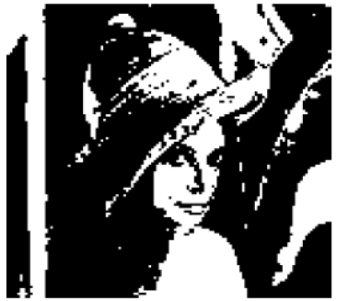
Monochrome 1-bit Lena image.
2. 8-bit images
Each pixel has a gray-value between 0 and 255. Each pixel is represented by a single byte; e.g., a dark pixel might have a value of 10, and a bright one might be 230. The Fig. 2 shows an 8-bit image.
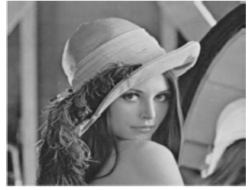
Grayscale image of Lena

Color Image Data Types
1. 24-bit images
In a color 24-bit image, each pixel is represented by three bytes, usually representing RGB. This format supports 256 ×256×256 possible combined colors, or a total of 16,777,216 possible colors. However such flexibility does result in a storage penalty: A 640×480 24-bit color image would require 921.6 kB of storage without any compression.
An important point: many 24-bit color images are actually stored as 32-bit images, with the extra byte of data for each pixel used to store an alpha value representing special effect information (e.g., transparency).
Fig. 3 shows the image forestfire.bmp. a 24-bit image in Microsoft Windows BMP format. Also shown are the gray scale images for just the Red, Green, and Blue channels, for this image.
(a): Example of 24-bit color image | (b): R color channels for this image
(c): G color channels for this image | (d): B color channels for this image
Fig.3: High-resolution color and separate R, G, B color channel images.

2. 8-bit Color Images
Many systems can make use of 8 bits of color information (the so-called \256 colors") in producing a screen image, this type of image called 8-bit Color Images. Such image files use the concept of a lookup table (جدول البحث) to store color information. Basically, the image stores not color, but instead just a set of bytes, each of which is actually an index into a table with 3-byte values that specify the color for a pixel with that lookup table index. Fig.4 shows the resulting 8-bit image, in GIF format.
Fig.4 Example of 8-bit color image.
Note the great savings in space for 8-bit images, over 24-bit ones: a 640×480 8-bit color image only requires 300 kB of storage, compared to 921.6 kB for a color image (again, without any compression applied).
Color Look-up Tables (LUTs)
The idea used in 8-bit color images is to store only the index, or code value, for each pixel. Then, e.g., if a pixel stores the value 25, the meaning is to go to row 25 in a color look-up table (LUT).
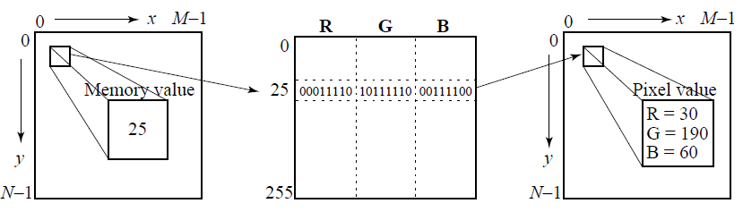
Fig. 5: Color LUT for 8-bit color images.
A Color-picker consists of an array of fairly large blocks of color (or a semi-continuous range of colors) such that a mouse-click will select the color indicated.
  - In reality, a color-picker displays the palette colors associated with index values from 0 to 255.
  - Each block of the color-picker corresponds to one row of the color LUT.
  - Fig. 6 displays the concept of a color-picker: if the user selects the color block with index value 2, then the color meant is cyan, with RGB values (0; 255; 255).
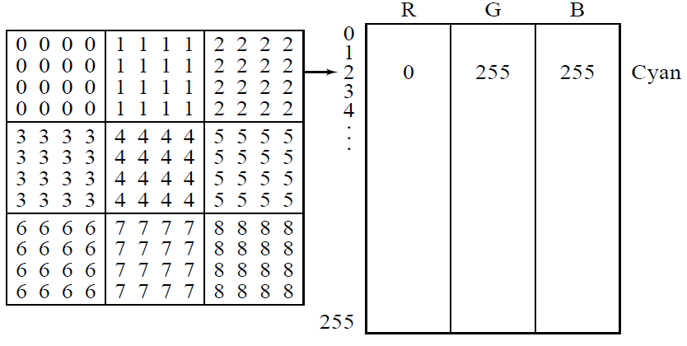
Fig.: 6 -picker for 8-bit color

Dithering For color:
Dithering is the attempt by a computer program to approximate a color from a mixture of other colors when the required color is not available. For example, dithering occurs when a color is specified for a Web page that a browser on a particular operating system can't support. Dithering: Mixing of colors, merging of pixels of different colors to create an area of intermediate color.
Color Map
The origin color +‎ map it is a kind of dictionary. Color mapping is a function that maps (transforms) the colors of one (source) image to the colors of another (target) image. A color mapping may be referred to as the algorithm that results in the mapping function or the algorithm that transforms the image colors. Color mapping is also sometimes called color transfer.
Convert between Color types
Convert from color image into gray scale image
For example: if we have sub color image as the following:
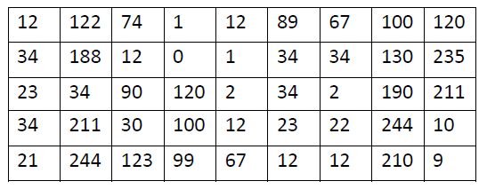
Convert it into gray scale image
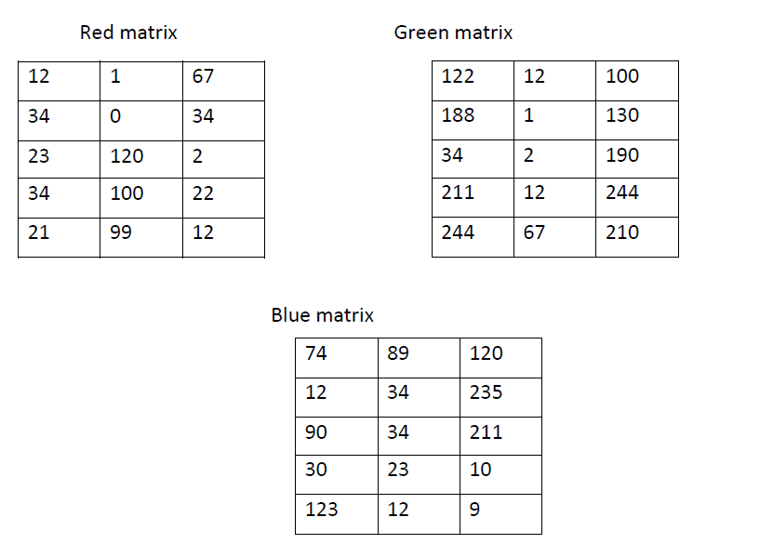
Gray Scale image= (red matrix + green matrix + blue matrix)/3
Note color image each pixel have 3 value represent 3 bands color (R, G and B).
69 | 34 | 95
78 | 11 | 133
49 | 52 | 134
91 | 45 | 92
129 | 59 | 77
Convert from gray scale image into binary image
For example if we have the following sub gray scale image
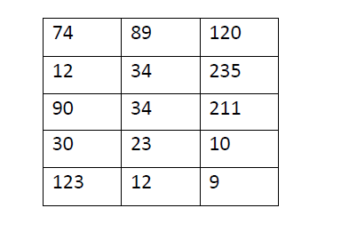
Convert into binary image
To convert image from gray scale image into binary image, we must have threshold value that help us in convert process. Therefore, before convert image we have select threshold value
There are two way to select threshold value
- Global threshold 128 as a middle value between [ 0 255]
- Adaptive threshold value
Step1: Select min and max value in all image
Step2: By using T1= (min + max)/2, consider T1 as initial threshold value
Step3: Find summation of all values that greater than T1 let is sum1 , and sum2 summation of all values less than T1.
Step4: Take average of sum1 and sum2 by divide each one on number of values. Av1= Sum1/ number of values same as with sum2 av2.
Step5: Adaptive threshold value = (Av1 + Av2 )/2
By using global threshold value to convert gray scale image into binary image. Consider T is a 128. Each pixel has value greater than T become 1 and vise versa
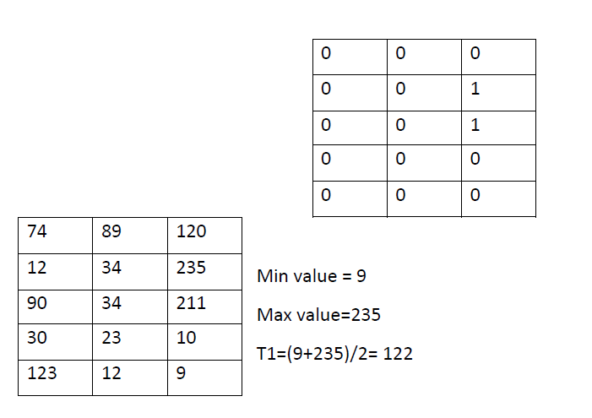
Sum1= [74+12+90+30+89+34+34+23+12+120+10+9] =537
Sum2= [123+235+211]= 569
Av1=sum1/ no of pixels = 537 / 12 = 44.75
Av2=sum2/ no of pixels = 569 / 3 = 189.6
Adaptive threshold value = [Av1 + Av2] / 2 =[ 44.75 + 198.6] /2= 117
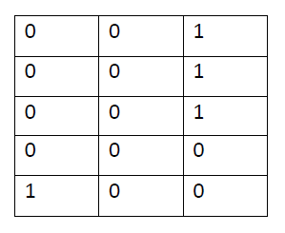
Color models (color space, or color system)
Color space is a mathematical model to represent color information as three or four different color components. Different color spaces (models) are used for different applications such as computer graphics, image processing, TV broadcasting, and computer vision. A color space is a standard approach to represent color in mathematical expressions. The chosen color space should be well appropriated to address the problems statement and solution. The operation of choosing the best color representation includes knowing what information are needs from these signals and how color signals are generated.
There are many color spaces in use today but there is no agreement on which one is the best: The RGB, YCbCr, YIQ, L*a*b*, and HSV color space.
The RGB Color Space
RGB color space is widely used and is normally the default color space for storing and representing digital images. We can get any other color space from a linear or non-linear transformation of RGB. The RGB color space is the color space used by computers, graphics cards and monitors or LCDs. RGB color space is defined as a unit cube with red, green and blue axes, as shown in figure bellow:

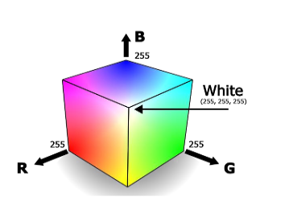
RGB Color Model
As shown in figure it consists of three components, red, green and blue, the primary colors. Any color can be obtained by mixing the three base colors. Although most of the images are in the RGB color space, this space is rarely used for querying and indexing because it does not correspond perfectly to the human color perception. Other color spaces are much better with respect to human perception and are more frequently used.
Defining RGB Colors for Computing
Specify intensity of RGB components typical range of intensity 0 – 255
$256 ×256 × 256 = 16,777,216$potential colors, 24-bit color
The RGB use 8-bits each, which have integer values from 0 to 255.
So the number of colors that can be generated, is:
$$256 ×256 × 256 = 16,777,216= 1000000_{16}$$
Each value is an unsigned 8-bit value:

HSV Color Space
HSV color space is the most intuitive way of describing color. This color system is very nearer than the RGB system to the approach in which humans express color sensations. As hue (H) varies from 0 to 1.0, the corresponding colors vary from red, through yellow, green, cyan, blue, and magenta, back to red. As saturation(S) varies from 0 to 1.0, the corresponding colors (hues) vary from unsaturated (shades of gray) to fully saturated (no white component). As value (V), or brightness, varies from 0 to 1.0, the corresponding colors become increasingly brighter. The hue component in HSV is in the range 0° to 360° angle all lying around a hexagon as shown figure bellow:
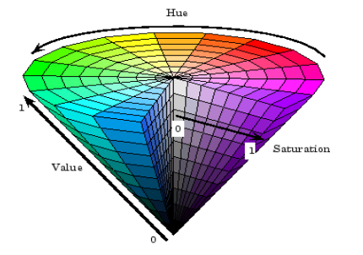
HSV Color Model
Its three components are derived from RGB values as follows:
where
HSV color space is a nonlinear conversion of the RGB, but it is readily invertible. The HSV model is very comparable to the HSL color model. The major difference between the two is the computation used to generate the brightness value.
The YIQ color model
It broadcast TV color system. This color space is used for TV/video in America and other countries where NTSC is the video Standard (Australia uses PAL). In this scheme Y is the luminance (this corresponds roughly with intensity), and I and Q carry the color information.
The advantage of this model is that more bandwidth can be assigned to the Y-component (luminance) to which the human eye is more sensible than to color information. The primary goals of the system were to provide a signal that could be directly displayed by black and white TVs, while also providing easy coding and decoding of RGB signals. This encoding is of far more importance for film & TV people than it is for computer graphics people, see figure bellow:
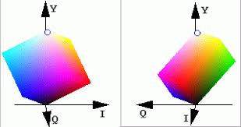
YIQ Color Space
The conversions from RGB to YIQ and back are given by the matrices:
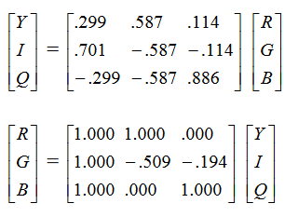
where obviously the two matrices are inverses.
L*a*b* color model
This color space is better suited to many digital image manipulations than the RGB space, which is typically used in image editing programs. For example, the Lab space is useful for sharpening images and the removing artifacts in JPEG images or in images from digital cameras and scanners.
In this color space, we have one channel is for Luminance (Lightness) and other two color channels are a and b known as chromaticity layers. The a* layer indicates where the color falls along the red-green axis, and b* layer indicates where the color falls along the blue-yellow axis, following figures clearly illustrate the coordinate system of l*a*b* color space
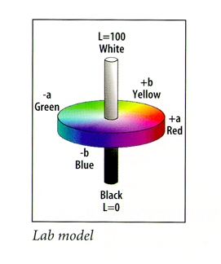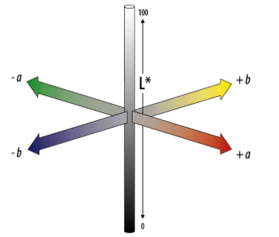
L*a*b* Color Space
• L scale: Light vs. dark where a low number (0-50) indicates dark and a high number (51-100) indicates light.
• a scale: Red vs. green where a positive number indicates red and a negative number indicates green.
• b scale: Yellow vs. blue where a positive number indicates yellow and a negative number indicates blue.
YCbCr (Luminance, Chrominance) Color Model
YCbCr is an encoded non-linear RGB signal, commonly used by European television studios and for image compression work as shown in figure bellow:
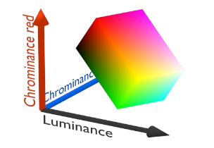
YCbCr Color Model

Color is represented by luma (which is luminance computed from non-linear RGB) constructed as a weighted sum of RGB values. YCbCr is a commonly used color space in digital video domain, because the representation makes it easy to get rid of some redundant color information, it is used in image and video compression standards like JPEG, MPEG1,MPEG2 and MPEG4.The transformation simplicity and explicit separation of luminance and chrominance components makes YCbCr color space.

In this format, luminance information is stored as a single component (Y), and chrominance information is stored as two color-difference components (Cb and Cr). Cb represents the difference between the blue component and reference value. Cr represents the difference between the red component and a reference value. YCbCr values can be obtained from RGB color space according to following equations:
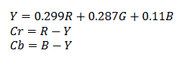
Idea behind the Transformation
Standard RGB to HSV Transform
The R,G,B values are divided by 255 to change the range from [0-255] to [0-1]:
$$R^{'}=\frac{ R}{255} Cmax = max(R', G', B')$$
$$G^{'}=\frac{ G}{255} Cmin = min(R', G', B')$$
$$B^{'}=\frac{ B}{255} Δ = Cmax - Cmin$$

Hue calculation:
$$H=\left\{\begin{aligned}60^{°}×(\frac{G^{'}-B^{'}}{∆}mod 6), if Cmax=R' \\ 60^{°}×(\frac{B^{'}-R^{'}}{∆}+2), if Cmax=G' \\ 60^{°}×(\frac{R^{'}-G^{'}}{∆}+4), if Cmax=B'\end{aligned}\right.$$
Saturation calculation:
$$S=\left(\left\{\begin{aligned} 0, if Cmax=0 \\ \frac{∆}{Cmax}, if Cmax≠0\end{aligned}\right.\right)×100\%$$
Value calculation:
$V =( Cmax$)$×100\%$

Example: Convert the RGB (0,255,0) to HSV ?
Solution:
$$R^{'}=\frac{ R}{255}=0 Cmax = max\left(R^{'}, G^{'}, B^{'}\right)=1$$
$$G^{'}=\frac{ G}{255}=1 Cmin = min\left(R^{'}, G^{'}, B^{'}\right)=0$$
$B^{'}=\frac{ B}{255} =0 Δ = Cmax – Cmin$=1
$$H=60^{°}×\frac{B^{'}-R'}{∆}+2, (because Cmax=G^{'})$$
$$H=60^{°}×\left(\frac{0-0}{1}+2\right)=60^{°}*2=120^{°}$$
$$S=\left(\left\{\begin{aligned} 0, if Cmax=0 \\ \frac{∆}{Cmax}, if Cmax≠0\end{aligned}\right.\right)×100\%$$
$$S=\left(\frac{1}{1}\right)×100\%=100\%$$
V =( Cmax) ×100 =1*100%=100%
RGB(0,255,0)=HSV(120,100%,100%)
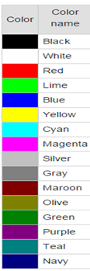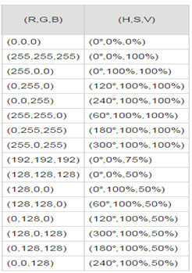
HSV to RGB conversion formula
When 0º ≤ H < 360º , 0 ≤ S ≤ 1 and 0 ≤ V ≤ 1:
$$C = V × S$$
$$X = C × (1 - |(\frac{H }{60°} ) mod 2 - 1|)$$
$$m = V – C$$
$${(R}^{'},G^{'},B')=\left\{\begin{aligned}\begin{matrix}\left(C,X,0\right) , 0°≤H<60° \\ \left(X,C,0\right), 60°≤H<120° \\ \begin{matrix}\left(0,C,X\right), 120°≤H<180° \\ \left(0,X,C\right), 180°≤H<240°\end{matrix}\end{matrix} \\ \left(X,0,C\right), 240°≤H<300° \\ \left(C,0,X\right), 300°≤H≤360°\end{aligned}\right.$$
$$(R,G,B) = (R'+m, G'+m, B'+m)$$

Example: Convert the HSV (120º,100%,100%) to RGB ?
Solution:
When 0º ≤ H < 360º , 0 ≤ S ≤ 1 and 0 ≤ V ≤ 1:
H=120º
S=1,
V=1,
C = V × S=1×1=1
$$X = C × \left(1 - \left|\left(\frac{H }{60°} \right)mod 2 - 1\right|\right)=1×\left(1-\left|\left(\frac{120° }{60°}\right)mod2-1\right|\right)=1×1\left(2 mod2-1\right)=1×(1-\left|\left(0-1\right)\right|=0$$
$m = V – C$=0
$${(R}^{'},G^{'},B')=\left(0,C,X\right)=(0,1,0)$$
$$\left(R,G,B\right)= \left(R^{'}+m, G^{'}+m, B^{'}+m\right)=\left(0+0,1+0,0+0\right)=(0,1,0)$$
$$\left(R,G,B\right)=\left(0,1,0\right)×255=(0,255,0)$$

RGB to Gray scale
Typical Grayscale conversion:
Gray = $0.3×R + 0.59× G + 0.11 × B$NOT
Gray = R / 3 + G / 3 + B / 3

